**Program no____11_____**

**Program Title______smart Package handling system _________**

**Aim The light Fades as the tilt sensor tilts**

**Hardware Required**

* Arduino Board
* LED
* Tilt sensor
* Resistor

**Circuit Diagram**

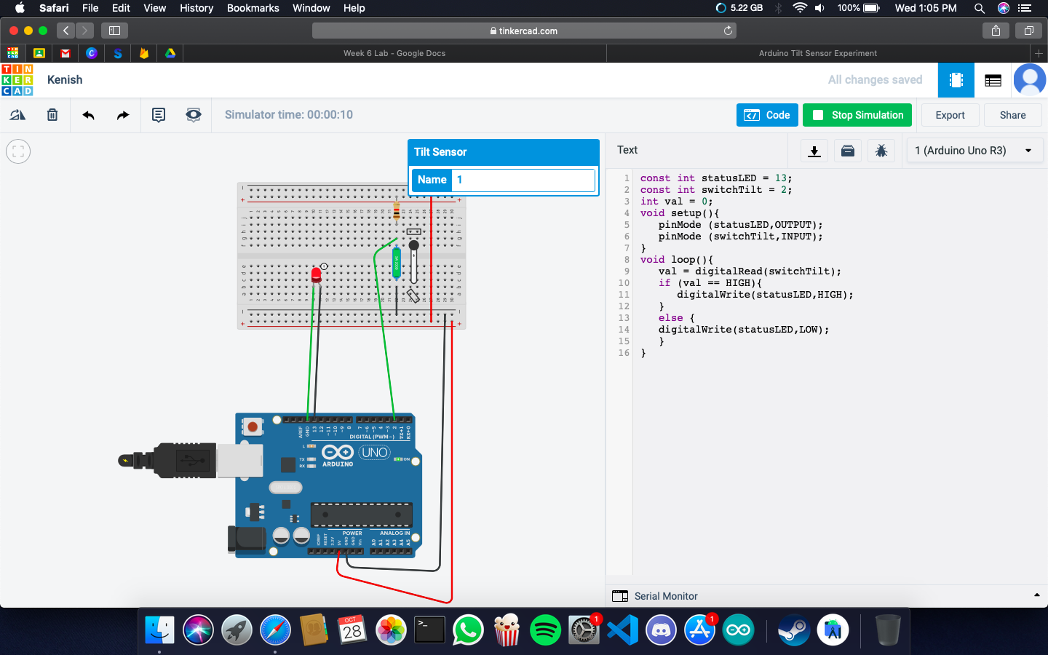

**Code:**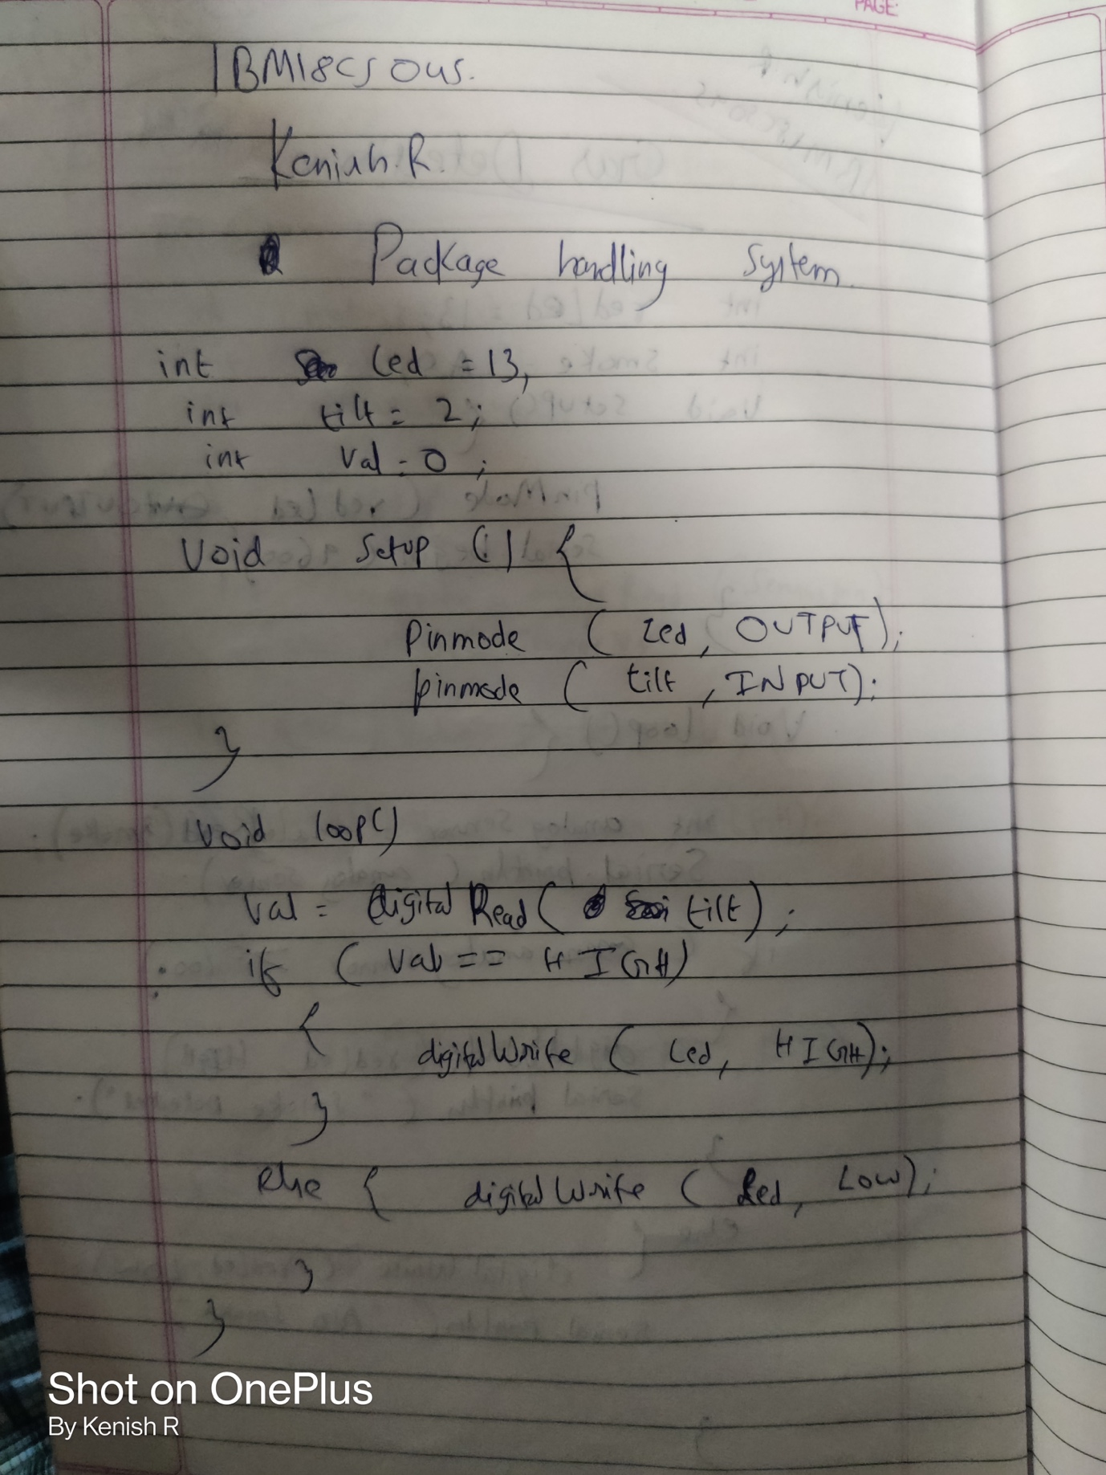

**Observation /Output**

**The light Fades as the tilt sensor tilts**